6.19

Today trading engine fucked up.

Put in 10 buy lots consecutively without delta check.

Pending orders weren’t taken into account of the delta and they all filled.

Different trader strategies need to be structured better.

1. Trim is for end of day cutting.
2. Opencover is for opening

Biggest source of pnl

1. Opening delta pnl
2. Should focus on, either open cover or

Today mistakes and problems

1. Index ma trader in the AM was trading randomly

Some analysis:

Intraday most volatile periods:

First hour and last hour

6.21.2018

Changes to index MA trading

1. At highs, sell more size, buy at price-margin, sell at p
2. At lows, buy more size, buy at price, sell at p+margin
3. Periodic order cancellation
4. pmchgY needs to be involved
5. Volatility needs to be involved in choosing size.

6.22.2018

Week analysis:

Negative corr between pm are obvious.

Glitches in the tool are many, there are bugs in the trading engine.

Overall advancing towards full automation.

Index MA trading:

* Keep working on this
* Involve volatility (especially overnight trading)
* Pm down -> cover -> general delta direction

Once operational

* Experiment with wider delta swings
* Experiment with quicker MA crosses at the open (1 & 5 min, only for the open half an hour)

Weekend analysis:

Stock: This week stocks were weak.

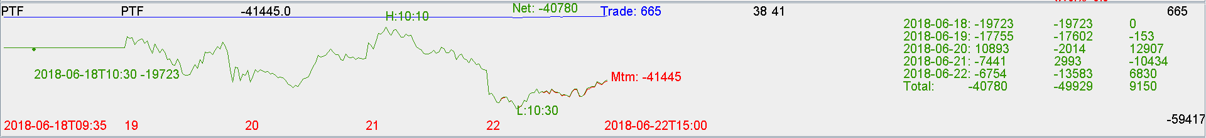

Futures:

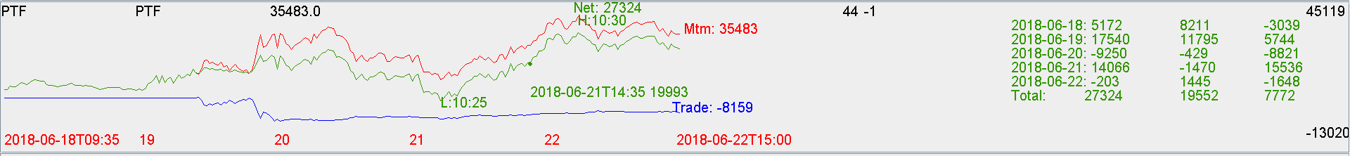

Mon: China was closed, future was up.

Tue: market opened low and maxF10 < close, this was a bad sign and nothing should have been traded. Engine had a glitch and bought 10 in the morning, caused the loss.

Wed: get rid of the hedge in the morning and put on long position in the PM to benefit from pmcl. Don’t want to hedge the PM. Didn’t remove enough of the hedge.

Thurs: PM crashed due to wed rise. Full hedge was put on in the AM by AM_HEDGE which was good.

Fri: a small pm rebound.

The short delta was effective in market turmoil.

Flipping delta direction will be important going forward. With pmchy down, you should flip delta instead of just covering delta. Being short at those points will yield negative pnl in expectation.

There will be bigger delta swings going forward.

MA trades, we will still experiment with small size in order to check the effectiveness.

Going forward, should be able to classify trading results based on strategy.

**Index ma only contributes to a small portion of trading pnl, the biggest source of alpha comes from trading big delta.**

The most important determinant is delta trading. MA trading is still counting for very small percentage of all trades.